# Theory Questions

* 1. Let there be and $b$ as required.

Let there be .

* 1. Let there be as required.

Let there be .

* 1. We will show that $l_{log}$ is convex:

$$\frac{dl_{log}}{dz}=\frac{-e^{-z}}{\left(1+e^{-z}\right)ln2}$$

$$\frac{d^{2}l_{log}}{dz^{2}}=\frac{e^{-z}\left(1+e^{-z}\right)ln2-\left(-e^{-z}\right)ln2{(-e}^{-z})}{{\left(\left(1+e^{-z}\right)ln2\right)}^{2}}=\frac{ln2e^{-z}+ln2e^{-2z}-ln2e^{-2z}}{{\left(\left(1+e^{-z}\right)ln2\right)}^{2}}$$

$$=\frac{ln2e^{-z}}{{\left(\left(1+e^{-z}\right)ln2\right)}^{2}}$$

Because $ln2>0,$ and for every $z∈R, e^{-z}>0$, the second derivative $\frac{d^{2}l_{log}}{dz^{2}}$ is positive for every $z∈R$, hence $l_{log}$ is convex.

In the first article of this question, we showed that for any convex function $f: R^{n}→R$, $A∈R^{n×n},$ and $b∈R^{n}$, $g\left(x\right)=f(Ax+b)$ is convex.

Therefore, if we take $y∈R, x∈R^{n}$, and set $b$ as the zero vector in $R^{n}$ we can conclude that $f: R^{n}→R, f\left(w\right)=l_{log}\left(yw∙x\right)$ is convex.

Because this is a composition of convex function with affine function, as in article (a).

1. We will prove that for $w_{hinge}^{*}∈argmin_{w∈R^{d}}\sum_{i=1}^{n}{l_{hinge}(y_{i}w∙x_{i})}$ satisfies that $∀i sign\left(w_{hinge}^{*}∙x_{i}\right)=y_{i}$.

First, we will prove the following **proposition**:

$for any r∈R, l_{zo}\left(r\right)≤l_{hinge}\left(r\right)$**,** when $l_{zo}\left(r\right)=\left\{\begin{aligned}0 r>0, \\ 1 r≤0\end{aligned}\right.,$

$l_{hinge}\left(r\right)=max⁡\{0, 1-r\}$.

Prove:

If $r>0,$ then $l_{hinge}\left(r\right)=\max\left\{0, 1-r\right\}≥0=l_{zo}\left(r\right)$

If $r≤0,$ then $l_{hinge}\left(r\right)=\max\left\{0, 1-r\right\}≥1=l_{zo}\left(r\right)$

Therefore, $for any r∈R, l_{zo}\left(r\right)≤l_{hinge}\left(r\right).$

Now we focus on proving that $w_{hinge}^{*}$ is also optimal for $l_{zo}.$

Let there be $i∈\left\{1,…,n\right\}, c∈R$.

Let us see how $cw^{*}$ behaves: $y_{i}cw^{*}∙x_{i}=cy_{i}w^{*}∙x_{i}>0$

Because $y_{i}w^{*}∙x_{i}>0$ for all $i$.

If we take $c>\frac{1}{y_{i}w^{*}∙x_{i}}$, we notice that $y_{i}cw^{*}∙x_{i}=cy_{i}w^{*}∙x_{i}>\frac{1}{y_{i}w^{*}∙x_{i}}∙y_{i}w^{*}∙x_{i}=1$,

Hence $l_{hinge}\left(y_{i}cw^{*}∙x_{i}\right)=0$

Using the hint, if we take $c→∞$, we get this constraint ($c>\frac{1}{y_{i}w^{*}∙x_{i}}$) for all $i$.

So, we conclude that for large enough $c$, $∀i l_{hinge}\left(y_{i}cw^{*}∙x_{i}\right)=0$,

So, $\sum_{i=0}^{n}{l_{hinge}(y_{i}cw^{*}∙x_{i})}=0$.

Therefore,

$$0≤\sum_{i=0}^{n}{l_{hinge}\left(y_{i}w_{hinge}^{*}∙x_{i}\right)}≤0$$

$$⇒\sum_{i=0}^{n}{l_{hinge}\left(y_{i}w_{hinge}^{*}∙x_{i}\right)}=0$$

$$⇒∀i l_{hinge}\left(y_{i}w_{hinge}^{*}∙x_{i}\right)=0$$

Where the last statements follow from the fact that $l_{hinge}$ is non-negative.

Because the hinge lost bounds the zero-one loss, we conclude that

$$∀i l_{zo}\left(y_{i}w_{hinge}^{*}∙x_{i}\right)=0$$

And this happens only if

$$∀i sign\left(w_{hinge}^{*}∙x_{i}\right)=y_{i}$$

Let there be $y∈R^{d}, x=\prod_{K}{\left(y\right)}$ it’s projection on $K$.

Because $K$ is convex, for any $λ∈\left(0, 1\right), z∈K$ we have that

$$λz+\left(1-λ\right)x=x+λ\left(z-x\right)∈K$$

Therefore, because ${\left\|x-y\right\|}_{2}=\min_{z∈K}{‖y-z‖}$

$${\left\|x-y\right\|}_{2}^{2}≤{\left\|x+λ\left(z-x\right)-y\right\|}_{2}^{2}$$

$$={\left\|x-y\right\|}_{2}^{2}+2λ\left\langle x-y\right.,\left.z-x\right\rangle +λ^{2}{\left\|z-x\right\|}_{2}^{2}$$

So, we conclude that $2λ\left\langle x-y\right.,\left.z-x\right\rangle ≥-λ^{2}{\left\|z-x\right\|}_{2}^{2}$.

From taking $λ→0$ we can see that $\left\langle x-y\right.,\left.z-x\right\rangle ≥0$

So,

$${\left\|y-z\right\|}_{2}^{2}={\left\|z-y\right\|}_{2}^{2}={\left\|z-x+x-y\right\|}_{2}^{2}$$

$$={\left\|z-x\right\|}_{2}^{2}+2\left\langle x-y\right.,\left.z-x\right\rangle +{\left\|x-y\right\|}_{2}^{2}$$

$$≥{\left\|z-x\right\|}_{2}^{2}$$

Where in the last inequality we used that $\left\langle x-y\right.,\left.z-x\right\rangle ≥0, {\left\|x-y\right\|}_{2}^{2}≥0.$  
and this yields us that ${\left\|y-z\right\|}_{2}≥{\left\|x-z\right\|}_{2}$

Let there be $x^{*}∈argmin_{x∈K}f(x)$, $η_{t}=\frac{ϵ}{G^{2}}$ and $T=\frac{B^{2}G^{2}}{ϵ^{2}}$ as in the Theorem.

I assume that ${\left\|x^{*}\right\|}_{2}^{2}≤B$, ${\left\|∇f\left(x_{t}\right)\right\|}_{2}^{2}≤G$ for every $x∈K$, and $x_{1}=0$ (like what was presented in Lecture #5).

Using Jensen inequality, we obtain that

$$f\left(\overline{x}\right)-f\left(x^{*}\right)=f\left(\sum_{t=1}^{T}{x_{t}}\right)-f\left(x^{*}\right)≤\frac{1}{T}\sum_{t=1}^{T}{f\left(x_{t}\right)}-f\left(x^{*}\right)=\frac{1}{T}\sum_{t=1}^{T}{(}f\left(x_{t}\right)-f\left(x^{*}\right))$$

Because $f$ is convex, we get that for any $t,$

$$f\left(x_{t}\right)-f\left(x^{*}\right)≤\left\langle ∇f(x_{t})\right.,\left.x_{t}-x^{*}\right\rangle$$

Thus,

$$f\left(\overline{x}\right)-f\left(x^{*}\right)≤\frac{1}{T}\sum_{t=1}^{T}{\left\langle ∇f(x_{t})\right.,\left.x_{t}-x^{*}\right\rangle }$$

And because $y_{t+1}=x_{t}-η_{t}∇f\left(x_{t}\right),$

we get that

$$f\left(\overline{x}\right)-f\left(x^{*}\right)≤\frac{1}{T}\sum_{t=1}^{T}{\left\langle ∇f\left(x_{t}\right)\right.,\left.x_{t}-x^{*}\right\rangle }≤\frac{1}{T}\sum_{t=1}^{T}{\frac{1}{η_{t}}\left\langle x_{t}-y_{t+1}\right.,\left.x_{t}-x^{*}\right\rangle }$$

Using completing the square we get that

$$\left(a-b\right)\left(a-c\right)=\frac{{\left(a-b\right)}^{2}+{\left(a-c\right)}^{2}-{\left(b-c\right)}^{2}}{2}$$

Therefore,

$$\frac{1}{η_{t}}\left\langle x_{t}-y_{t+1}\right.,\left.x_{t}-x^{*}\right\rangle$$

$$=\frac{1}{{2η}_{t}}\left({\left\|x_{t}-y_{t+1}\right\|}_{2}^{2}+{\left\|x_{t}-x^{*}\right\|}_{2}^{2}-{\left\|y_{t+1}-x^{*}\right\|}_{2}^{2}\right)$$

And if we again use that $y_{t+1}=x_{t}-η_{t}∇f\left(x_{t}\right),$ we get

$$=\frac{1}{{2η}_{t}}\left({\left\|x_{t}-x^{*}\right\|}_{2}^{2}-{\left\|y_{t+1}-x^{*}\right\|}_{2}^{2}\right)+\frac{η_{t}}{2}{\left\|∇f\left(x_{t}\right)\right\|}_{2}^{2}$$

From article (a), we obtain that

$${\left\|x_{t+1}-x^{*}\right\|}_{2}≤{\left\|y_{t+1}-x^{*}\right\|}_{2}$$

And this is the same as

$$-{\left\|x_{t+1}-x^{*}\right\|}_{2}≥-{\left\|y_{t+1}-x^{*}\right\|}_{2}$$

So, if we plug this into the upper formula, we get that

$$\frac{1}{{2η}_{t}}\left({\left\|x_{t}-x^{*}\right\|}_{2}^{2}-{\left\|y_{t+1}-x^{*}\right\|}_{2}^{2}\right)+\frac{η_{t}}{2}{\left\|∇f\left(x_{t}\right)\right\|}_{2}^{2}$$

$$≤\frac{1}{{2η}_{t}}\left({\left\|x_{t}-x^{*}\right\|}_{2}^{2}-{\left\|x_{t+1}-x^{*}\right\|}_{2}^{2}\right)+\frac{η_{t}}{2}{\left\|∇f\left(x_{t}\right)\right\|}_{2}^{2}$$

For conclusion, we got that

$$\frac{1}{η_{t}}\left\langle x_{t}-y_{t+1}\right.,\left.x_{t}-x^{*}\right\rangle ≤\frac{1}{{2η}_{t}}\left({\left\|x_{t}-x^{*}\right\|}_{2}^{2}-{\left\|x_{t+1}-x^{*}\right\|}_{2}^{2}\right)+\frac{η_{t}}{2}{\left\|∇f\left(x_{t}\right)\right\|}_{2}^{2}$$

So,

$$f\left(\overline{x}\right)-f\left(x^{*}\right)≤\frac{1}{T}\sum_{t=1}^{T}{\frac{1}{η_{t}}\left\langle x_{t}-y_{t+1}\right.,\left.x_{t}-x^{*}\right\rangle }$$

$$≤\frac{1}{T}\sum_{t=1}^{T}{\left(\frac{1}{{2η}_{t}}\left({\left\|x_{t}-x^{*}\right\|}_{2}^{2}-{\left\|x_{t+1}-x^{*}\right\|}_{2}^{2}\right)+\frac{η_{t}}{2}{\left\|∇f\left(x_{t}\right)\right\|}_{2}^{2}\right)}$$

$$=\frac{1}{2Tη_{t}}\left({\left\|x_{1}-x^{*}\right\|}_{2}^{2}-{\left\|x_{T+1}-x^{*}\right\|}_{2}^{2}\right)+\frac{η_{t}}{2T}{\left\|∇f\left(x_{t}\right)\right\|}_{2}^{2}$$

$$≤\frac{1}{2Tη_{t}}{\left\|x_{1}-x^{*}\right\|}_{2}^{2}+\frac{η_{t}}{2T}{\left\|∇f\left(x_{t}\right)\right\|}_{2}^{2}≤\frac{1}{2Tη_{t}}{\left\|x^{*}\right\|}_{2}^{2}+\frac{η_{t}}{2}{\left\|∇f\left(x_{t}\right)\right\|}_{2}^{2}$$

$≤\frac{B^{2}}{2Tη_{t}}+\frac{η_{t}}{2}G^{2}=\frac{B^{2}}{ 2}\frac{G^{2}ϵ^{2}}{{ϵB}^{2}G^{2}}+\frac{ϵ}{2G^{2}}G^{2}=\frac{ϵ}{2}+\frac{ϵ}{2}=ϵ$

1. Let there be $f:R^{n}→R$ as in the question (differential, non-negative and $β$ smooth). Let us consider $x_{t}, x_{t+1}$ points in GD, where $η<\frac{2}{β}$.

Because $f$ is $β$ smooth:

$$f\left(x_{t+1}\right)≤f\left(x_{t}\right)+∇f{\left(x_{t}\right)}^{T}\left(x_{t+1}-x_{t}\right)+\frac{β}{2}{\left\|x_{t+1}-x_{t}\right\|}^{2}$$

$$=f\left(x_{t}\right)-η∇f{\left(x_{t}\right)}^{T}∇f\left(x_{t}\right)+\frac{βη^{2}}{2}{\left\|∇f\left(x_{t}\right)\right\|}^{2}$$

$$=f\left(x_{t}\right)-{\left\|∇f\left(x_{t}\right)\right\|}^{2}\left(η-\frac{β}{2}η^{2}\right)$$

Therefore,

$${\left\|∇f\left(x_{t}\right)\right\|}^{2}≤{\left(η-\frac{β}{2}η^{2}\right)}^{-1}\left(f\left(x_{t}\right)-f\left(x_{t+1}\right)\right)$$

Let’s denote $S_{n}=\sum_{t=1}^{n}{{\left\|∇f\left(x_{t}\right)\right\|}^{2}}$ the partial sums sequence.

We obtain from the above that:

$$S_{n}≤{\left(η-\frac{β}{2}η^{2}\right)}^{-1}\left(f\left(x_{1}\right)-f\left(x_{n+1}\right)\right)$$

Let us calculate when $η-\frac{β}{2}η^{2}>0$:

$$η-\frac{β}{2}η^{2}>0⇔η\left(1-\frac{β}{2}η\right)>0⇔0<η<\frac{2}{β}$$

And from our assumptions, this holds.

So, we can use that $∀x∈R^{n}, f\left(x\right)≥0$ to obtain:

$$S_{n}≤{\left(η-\frac{β}{2}η^{2}\right)}^{-1}f\left(x_{1}\right)$$

This means that $S_{n}$ is bounded from above by non-negative number:

$${\left(η-\frac{β}{2}η^{2}\right)}^{-1}f\left(x_{1}\right)$$

We notice that $S_{n+1}≥S_{n}$, because

${S_{n+1}=S_{n}+\left\|∇f\left(x_{n+1}\right)\right\|}^{2}≥S_{n}$ ($∀t∈N {\left\|∇f\left(x_{n+1}\right)\right\|}^{2}≥0$)

This means that $S_{n}$ converges because non-decreasing and bounded from above sequence converges to its supremum.

Therefore $\lim_{t→∞}{{\left\|∇f\left(x_{t}\right)\right\|}^{2}}=0$ from the hint, and therefore $\lim_{t→∞}\left\|∇f\left(x_{t}\right)\right\|=0$

(If $\lim_{n→∞}{a_{n}^{2}}=0$, then $\lim_{n→∞}{a_{n}}=0$).

# Programming Questions

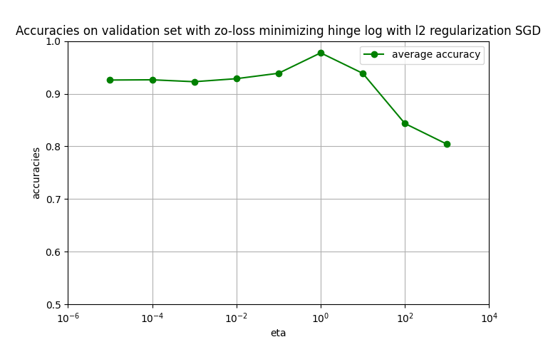

When $η$ was larger than $1000$ there overflow encountered in multiplication, so we tested up to $η=1000$.

The best $η$ is 1.

1. 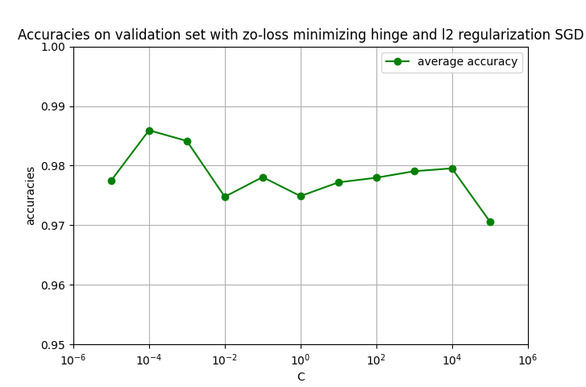

The best $C$ is 0.0001.

1. 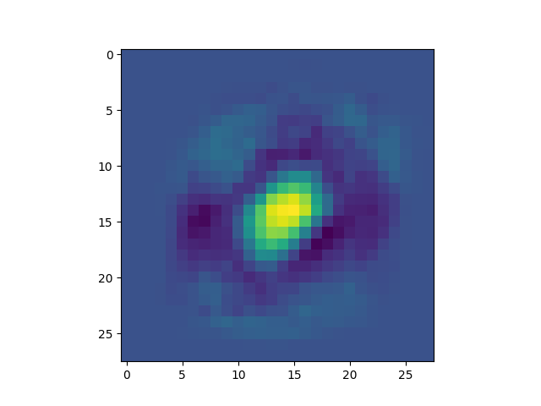

We can interpretate that the “warmer” the color, the result of SGD is denser, and when the color is “cooler”, it’s sparser.

1. The accuracy on the test dataset is 99.28352098259979%.
   1. Chart, line chart

      Description automatically generated

The best is 0.1.

* 1. Chart

     Description automatically generated with medium confidence

The accuracy is 75.84442169907881%.

* 1. 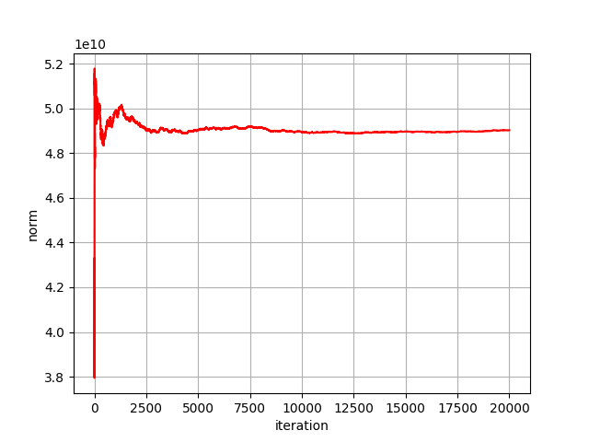

We can see that the norms sequence converges.

We know that in expectation SGD converges to the optimal point.

Probably, this number of iterations was large enough for SGD to convert for optimum, and because of that the norms sequence convergent to the norm of the optimum.